WHEREAS, the week of April 3-9, 2023, is National Public Health Week, and the theme is “Centering and Celebrating Cultures in Health”; and

WHEREAS, since 1995, the American Public Health Association, through its sponsorship of National Public Health Week, has educated the public, policymakers, and public health professionals about issues important to improving the public’s health; and

WHEREAS, United States life expectancy dropped sustainably since the Great Recession from 2014 to 2017 and in 2018 began to increase again only to then drop again in 2020 by a full year, which is the largest drop in life expectancy since 1943; and

WHEREAS, there is a significant difference in health status — obesity, poor mental health, and drug use — among people living in rural areas compared with those living in urban areas, and this variance increases because rural residents are often more likely to face social determinants that negatively impact health such as poverty, transportation barriers and lack of economic opportunity; and

WHEREAS, a person’s health status can differ drastically by zip code due to differences in the built environment, environmental quality, community context, and access to healthy food, education, and health care; and

WHEREAS, public health professionals assist communities with the prevention of, preparation for, and recovery from a full range of health threats — including disease outbreaks, measles, and natural disasters; and

WHEREAS, the actions of these professionals along with scientific and technological advances, has played a major role in reducing, and in some cases, eliminating the spread of infectious disease as well as establishing today’s disease surveillance and control systems; and

WHEREAS, each year in the United States 7 of every 10 deaths are caused by chronic diseases, which occur from preventable risk factors such as physical inactivity, poor nutrition, tobacco use, and excessive alcohol; and

WHEREAS, the first week of April is designated to bring communities together across the United States to recognize the contributions of public health and to learn what can be done to improve the health status of those around us.

NOW, THEREFORE, I, John R. Heath, Acting Mayor of the City of Salisbury, do hereby proclaim April 3-9 as

“NATIONAL PUBLIC HEALTH WEEK 2023”

in our City and invite all citizens to observe this week by helping our families, friends, neighbors, co-workers, and leaders to better understand the value of public health and supporting great opportunities to adopt preventive lifestyle habits.

IN WITNESS THEREOF, I hereunto set my hand and the seal of the City of Salisbury this 3rd day of April 2023.

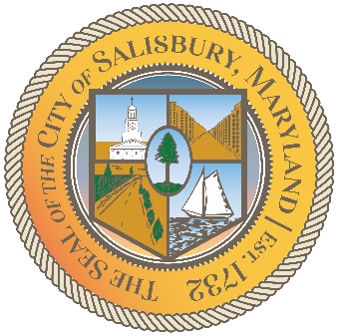
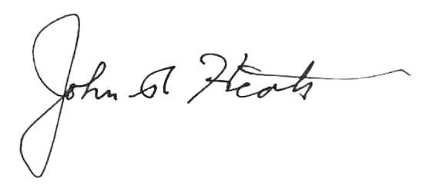

______________________
John R. Heath, Acting Mayor

